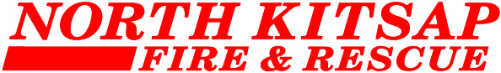

MEETING NOTICE
February 12, 2024, at 7:00 p.m.

The Board of Fire Commissioners meeting will be held in person at Station 81 (26642 Miller Bay Rd NE, Kingston) and available for remote attendance.

A call-in number has been set up so members of the public can listen to the meeting. Just prior to 7:00 p.m. please call 323-591-8434, when prompted, enter the following Conference ID: 293 247 070 then press #.

Those attending remotely with questions prior to, and during the meeting should email Summer Luther at Luther@nkfr.org.

