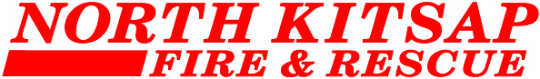

MEETING NOTICE
October 11th, 2021 at 7:00 p.m.

In accordance with guidelines in place to limit the spread of COVID-19, our October 11th Board of Fire Commissioners meeting will be held remotely via Microsoft Teams.

A call-in number has been set up so members of the public can listen to the meeting. Just prior to 7:00 p.m. please call 323-591-8434, when prompted, enter the following Conference ID: 874 573 869 then press #.

Questions prior to, and during the meeting should be emailed to Summer Luther at Luther@nkfr.org.

